**A Journey from a Homemaker to a Progressive Farmer**

**Name:** Rupa Murmu  
**Husband's Name:** Haldhar Murmu  
**Village:** Dholadih  
**Panchayat:** Chandpur  
**Block:** Potka  
**District:** East Singhbhum

Rupa Singh, a determined woman from Dholadih village in Potka block, East Singhbhum district, has become a symbol of change and inspiration in her community. While her husband, Haldhar Singh, works as a laborer in the city to support their family, Rupa took it upon herself to bring a meaningful transformation at home.

She became an **active member of the Bhumij Kisan Club Samiti**, a farmers’ collective formed with the support of **Samekit Jan Vikas Kendra, Patel Bagan**. Through this platform, Rupa came in contact with new ideas and training opportunities related to sustainable agriculture and income generation.

Her journey began with a training session provided by the **Samekit Jan Vikas Kendra**, where she learned the basics of **kitchen gardening**. Motivated by the training, Rupa started a small kitchen garden beside her house. With minimal investment and care, she began growing seasonal vegetables like spinach, brinjal, and tomatoes. This initiative proved extremely beneficial, as it not only provided fresh, chemical-free vegetables for her family but also helped her save **Rs. 600 to 700 every month** on household vegetable expenses.

Encouraged by this success, Rupa decided to explore more advanced farming methods. In **January 2023**, she underwent **machan farming training** conducted by Samekit Jan Vikas Kendra. Machan farming involves vertical cultivation using bamboo structures and ropes—an ideal solution for maximizing yield in small landholdings.

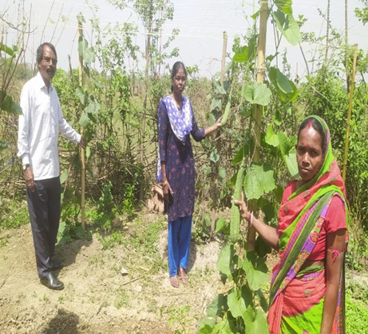

Using this technique, Rupa prepared **30 decimals of land** near her house. With the help of **ropes, bamboo poles, pegs, and local materials**, she constructed a sturdy machan and planted **jhingi (ridge gourd)** and **karela (bitter gourd)**. Though the season was affected by **excessive heat**, which somewhat reduced the overall yield, her hard work paid off.

By the end of the harvest season, Rupa had produced **205 kg of jhingi** and **108 kg of karela**. She sold the vegetables at **Rs. 40 per kg**, earning a **total of Rs. 12,520**. This income was a huge support to her family, especially since she managed it from her own village without migrating or stepping far from her household responsibilities.

Looking ahead with excitement, Rupa now plans to plant **barbadhi (sponge gourd)** and **bitter gourd** in the upcoming **Kharif season** using the same machan structure. Her confidence has grown, and so has the admiration she receives from other women in the village, who now see her as a role model.