**A New Path in Farming: The Inspiring Journey of Ghono Ho**

My name is Ghono Ho, and my father’s name is Pogro Ho. I belong to Porabhumri village, located in Chandpur Panchayat of East Singhbhum district, Jharkhand. There are six members in my family. Earlier, we used to rely solely on paddy farming, which barely met our daily food needs. Due to limited income, our family often faced financial hardships.

**A New Direction Through Agricultural Training**

In 2022, a meeting was held in the village to inform farmers about income generation through farming. During this meeting, Bhagat Sir and Rothin Sir from Catholic Charities provided training on modern farming techniques and vegetable cultivation. I began actively participating in the meetings of Maa Mansa Kisan Club and gradually gained new insights into agriculture.

**First Steps into Farming (2022)**

In October 2022, I started vegetable cultivation on 10 decimals of land. Using the seeds provided by the organization, I cultivated spinach, radish, and chili. From this initiative, I earned a total income of Rs. 12,500. This initial success motivated me to expand my farming activities.

**Expansion of Farming (2023)**

In 2023, I increased my farming area to 20 decimals, growing spinach, mustard, radish, and tomatoes. I invested Rs. 1,000 as my own capital, and this time, I earned a total income of Rs. 22,500. The increase in income encouraged me to work even harder.

**Moving Toward Major Success (2024)**

In 2024, I further expanded my farm to 40 decimals, investing Rs. 2,500 to cultivate spinach, radish, mustard, tomatoes, and brinjals. This effort yielded a total income of Rs. 42,400, out of which I deposited Rs. 10,000 in the bank. It was a moment of great pride for me, as I was now not only supporting my family but also managing to save for the future.

**A New Attempt in September 2024**

In September 2024, I expanded my farm once again to 60 decimals, investing Rs. 5,000 in vegetable cultivation. From the first phase of harvest, I have already earned Rs. 32,200, while the second phase is yet to be sold. I am confident that this season’s income will surpass the previous one.

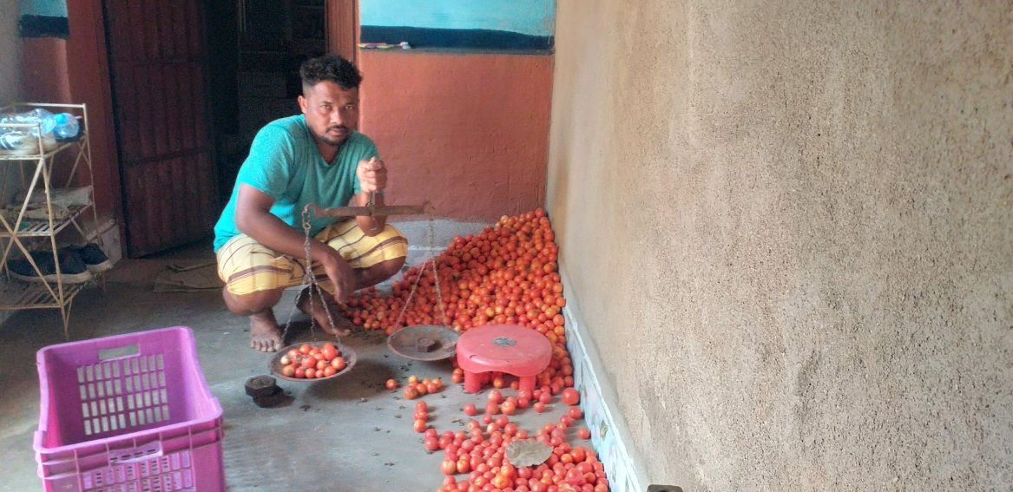

**Outcome and Future Plans**

Today, thanks to my hard work and the guidance received from the organization, I am living a prosperous and dignified life. I now plan to experiment with new farming methods, adopt advanced techniques, and inspire fellow farmers in my village.

Through the support of Catholic Charities and my mentors, I have learned that with the right guidance and sincere efforts, success in any field is achievable. I wholeheartedly thank the organization and the trainers, whose support helped me transform my life.

**Summary of Ghono Ho's Agricultural Progress**

| **Year** | **Land (Decimals)** | **Crops Grown** | **Capital (Rs.)** | **Total Income (Rs.)** | **Bank Savings (Rs.)** |
| --- | --- | --- | --- | --- | --- |
| 2022 | 10 | Spinach, Radish, Chili | Seeds from org | 12,500 | - |
| 2023 | 20 | Spinach, Mustard, Radish, Tomato | 1,000 | 22,500 | - |
| 2024 (Phase 1) | 40 | Spinach, Radish, Mustard, Tomato, Brinjal | 2,500 | 42,400 | 10,000 |
| 2024 (Sep Phase 2) | 60 | Vegetable Farming | 5,000 | 32,200* | - |