**Hard Work Changed My Fate**

I am Ramesh Nayak, a resident of Moreng village in Anandpur block, West Singhbhum district, Jharkhand. My family of seven relied primarily on paddy farming, and for years, we only grew enough to sustain ourselves. While we occasionally cultivated vegetables, it was only for home consumption.

**A New Beginning**

Everything changed when I joined the Jago Farmers' Club, a program run by Catholic Charities in our village. The training sessions I attended transformed my perspective on farming. I learned innovative techniques such as preparing organic fertilizers, natural pest repellents, and the use of "Amrit Pani" to enhance crop growth. These methods helped me understand how to improve productivity using sustainable practices.

Encouraged by Jageswar, a field staff from the organization, I decided to experiment with vegetable farming on 30 decimal land. She also assisted me in purchasing seeds, boosting my confidence. I invested ₹1,200 in seeds and, for the first time, approached farming with dedication and strategy.

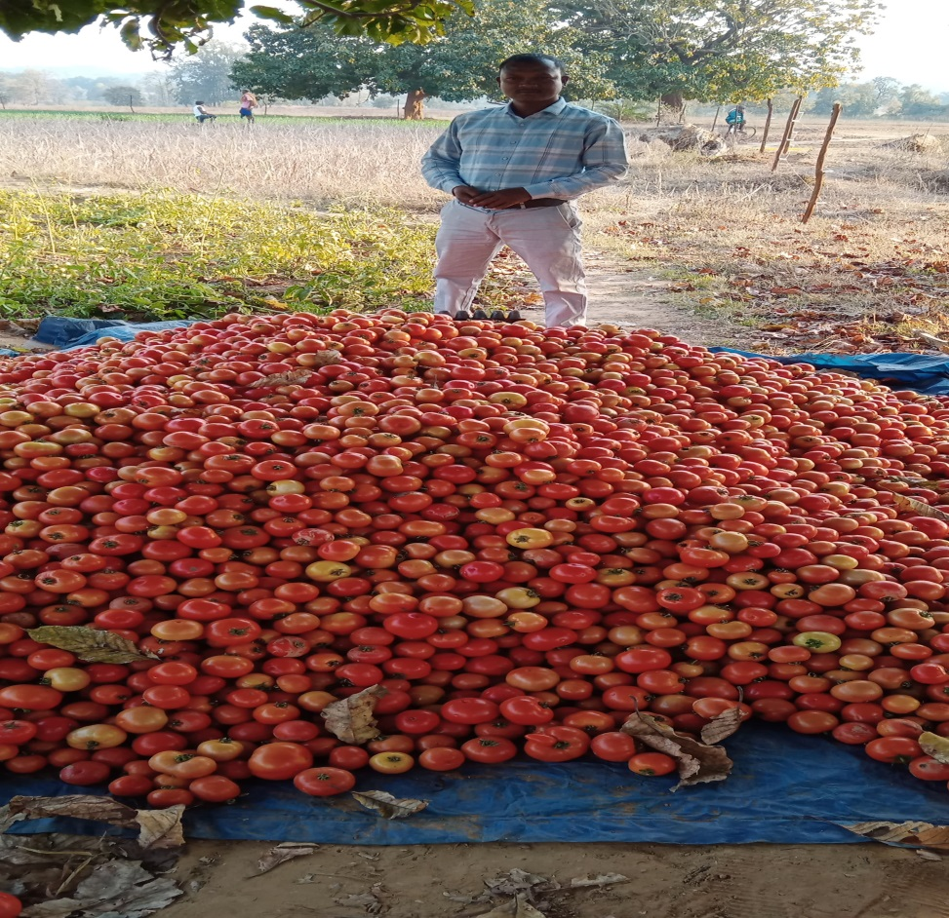

**A Brighter Future**

Today, I cultivate vegetables on nearly one acre of land. The financial stability from farming has transformed my family's life. My son is now enrolled in an English-medium school, and our household is no longer struggling to make ends meet.

I am deeply grateful to Catholic Charities, especially Jageswar, Bhagat Ji, and Rothin Sir, whose guidance and support helped me achieve this success. Their encouragement gave me a new direction and purpose in life.

From a struggling farmer to a successful vegetable grower, my journey proves that with knowledge, perseverance, and the right support, hard work can indeed change one’s fate.