**From Livestock Rearing to Thriving Vegetable Farming**

I am Ursula Jojo from Buribil village, Berakenduda Panchayat, Anandpur Block. My family consists of eight members, and my husband works as a laborer. Due to financial struggles, our household often faced hardships. However, my determination to improve our situation led me to join the "Uday Kisan Club" in 2023.

Through regular participation in the farmer club meetings, I gained valuable insights into agriculture. Although I had land for farming, I lacked the necessary capital to invest in it. During one such meeting, Jageswar, a field staff from the organization, advised me to utilize my existing livestock resources. She suggested selling some of my goats to generate funds for farming. Taking her advice, I sold 4 goats for ₹12,000 and invested this amount in cultivating vegetables on my 40 decimal land.

I began growing chilli, tomato,spinach, fenugreek, cauliflower, and potatoes. Within a month, I started selling leafy greens in the local market, earning a daily income of ₹300 to ₹500. Over six months, my total earnings reached ₹48,200. This steady income brought financial relief and stability to my family.

Recognizing my efforts, Rothin Sir and Bhagat Sir from the organization visited my farm for an inspection. They advised me on adopting line sowing techniques and using pest-resistant medicines to improve productivity. Implementing their suggestions further enhanced my yield and profits.

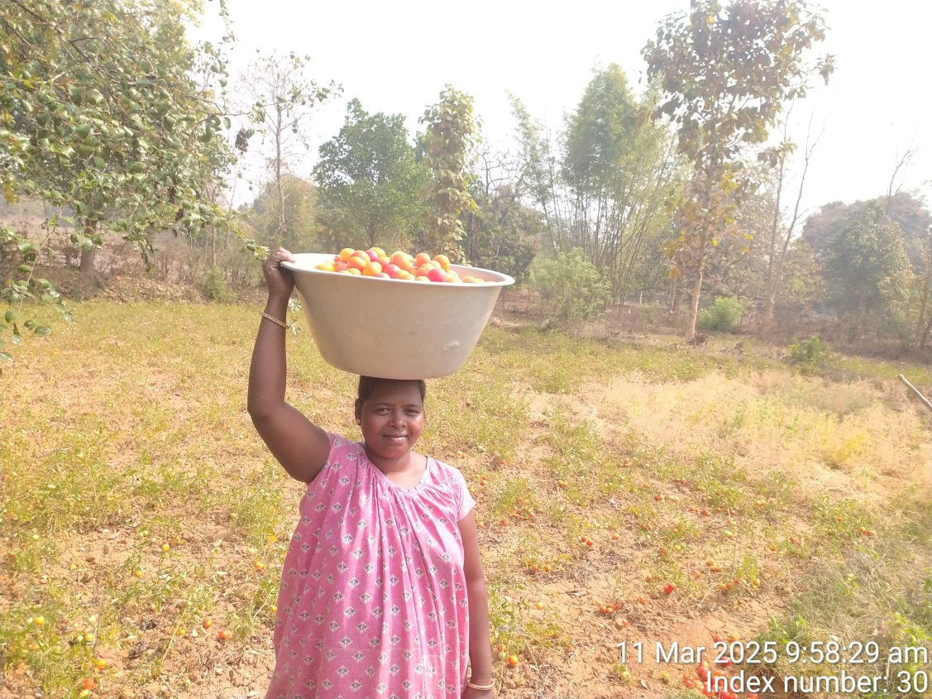

Today, I am proud to say that my journey from livestock rearing to vegetable farming has transformed my life. I am immensely grateful to Catholic Charities for their valuable guidance and encouragement. Their support has empowered me to achieve financial independence and improve my family's livelihood.

Now, I aspire to expand my farming activities and inspire other women in my village to take up agriculture as a means of self-reliance and empowerment.