**Transforming Life through Agriculture and Animal Husbandry**

Peter Horo, a dedicated farmer from Taropdanda village, Bera Kenduda Panchayat, Anandpur Block, West Singhbhum District, Jharkhand. His determination and willingness to embrace modern agricultural techniques helped him overcome financial struggles and improve his family’s livelihood.

**Background**

Peter Horo comes from a family of seven, including his parents, wife, two daughters, and a son. The family relied entirely on traditional farming, which was insufficient to meet their basic needs. Food scarcity was a constant concern, and there were times when they did not even have rice at home. Financial hardships also affected the education of his children, limiting them to government schools, and celebrating festivals became a luxury they could not afford. Managing the household expenses was a continuous struggle.

**Challenges Faced**

Initially, Peter cultivated vegetables on only 8 to 10 decimals of land, which was not enough to provide sufficient vegetables throughout the year. The lack of modern agricultural knowledge and financial resources restricted his ability to improve farm productivity.

**Intervention and Training**

In 2019, Peter met a worker from Catholic Charities, who introduced him to better farming techniques. Inspired by their advice, he decided to attend agricultural training in Jamshedpur organized by the same organization. There, he learned about improved vegetable farming methods as well as animal husbandry.

After returning from the training, Peter and other farmers in his village formed a Farmers' Club, naming it Prakash Kisan Club. He joined as a member and actively participated in the meetings. The organization later arranged training in Hazaribagh, which provided him with advanced knowledge on integrated agriculture and modern farming techniques.

**Implementation of Learning’s**

After gaining expertise from the training programs, Peter took a bold step by expanding his farmland. He increased his farming area to 40 decimals and diversified his crops, growing tomatoes, long beans, maize, and yam. With improved farming techniques, his crop yield improved significantly. As a result, he earned ₹48,000 from selling vegetables in the market.

With this income, he made further investments:

* Purchased fencing material for one acre of land to secure his farm.
* Bought two goats to start livestock farming.
* Adopted year-round vegetable farming to ensure a steady income.

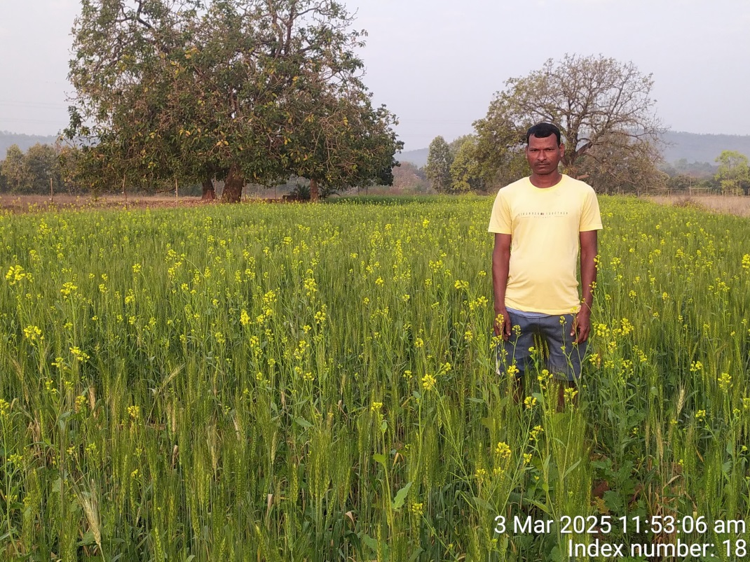

**Financial Growth and Stability**

Peter's consistent efforts and expanded farming activities yielded remarkable results. His annual earnings from vegetable farming increased to ₹1,10,000. Additionally, poultry and goat farming provided him with an extra income of ₹20,000 to ₹25,000 per year.

Currently, Peter owns 18 goats, and his family’s financial situation has improved drastically. With his earnings, he achieved the following milestones:

* Enrolled his younger son and daughter in a private school for better education.
* Supported his elder son in motor training to help him build a career.
* Built a five-room house for his family, ensuring better living conditions.

**Impact and Future Prospects**

Peter Horo’s transformation from a struggling farmer to a successful entrepreneur serves as an inspiration to other farmers in his community. His journey emphasizes the importance of:

* Acquiring modern agricultural knowledge.
* Utilizing government and organizational support for training and resources.
* Diversifying farming activities to ensure sustainable income.

Peter expresses his heartfelt gratitude to Catholic Charities and every member of the organization for their invaluable guidance and support in helping him achieve success.