**Adopting Integrated Farming: The Story of Johan Kerketta**

**Name:** Johan Kerketta  
**Age:** 53  
**Education:** Illiterate  
**Family Members:** 6  
**Village:** Taropdanda  
**Panchayat:** Bera Kenduda  
**Block:** Anandpur  
**District:** West Singhbhum, Jharkhand

**Struggles and Initial Challenges**

Johan Kerketta, a resident of Taropdanda village, primarily depended on paddy farming and daily wage labor to support his family. He earned only ₹100 per day, which was insufficient to meet his family’s needs. Financial difficulties made it challenging to provide for his household, forcing him to look for alternative sources of income.

**Turning Point: Introduction to Integrated Farming**

In November 2020, Johan attended a farmers' meeting organized by Catholic Charities. During this meeting, field coordinators Jageshwar, project coordinator Ramkrishna, and Rothin explained how farmers could improve their livelihoods through better agricultural practices and integrated farming. They highlighted how farming could be made more profitable and sustainable.

Following the meeting, Johan received seeds and technical support from the organization. He decided to experiment by planting radish, onions, mustard, and spinach on 20 decimals of land.

**Gradual Success and Income Growth**

* By December 2020, Johan earned ₹500 from his first harvest of mustard greens and spinach. His 30 days of effort started yielding results.
* From the second vegetable harvest, he made ₹2,000, which helped him buy essential household items like soap, oil, and spices.
* Encouraged by this success, in February 2021, he reinvested ₹1,000 in his farm, expanding cultivation to 20 decimals of land. He grew tomatoes, leafy greens, and chili peppers, earning a total profit of ₹9,500.

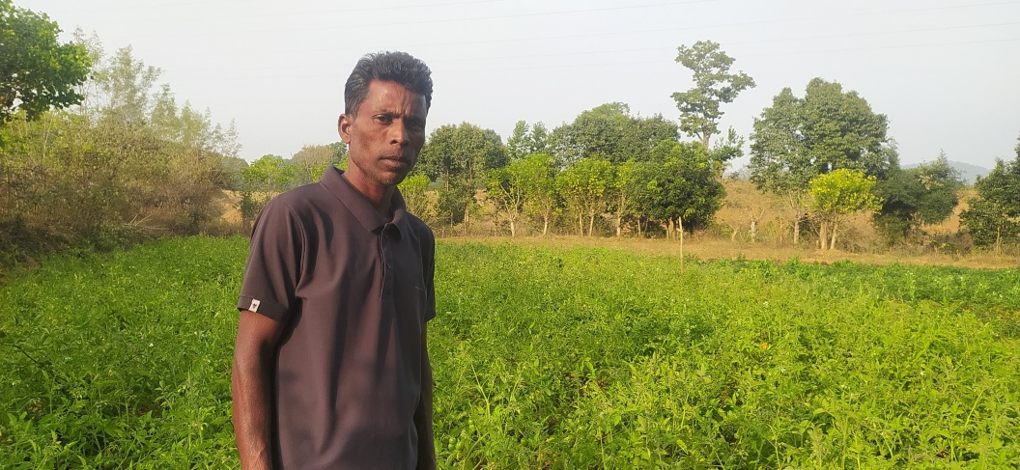

**Expansion and Higher Profits**

In 2022, Johan decided to scale up his farming efforts:

* He invested ₹3,000 and expanded his farmland to 40 decimals.
* He cultivated spinach, chili, tomatoes, and cauliflower, generating a total income of ₹24,250.
* Seeing the benefits of integrated farming, he also began poultry and duck farming, diversifying his income sources.

**By 2024, Johan had expanded further:**

* He cultivated 50 decimals of land, investing ₹4,000.
* This time, he included finger millet (madwa) along with vegetable farming to maximize his earnings.