**Sowing Seeds of Change: Sumitra Singh’s Path to Financial Independence**

The inspiring journey of Sumitra Devi, a resident of beratulunda village, berakenduda Panchayat, anandpur Block. Sumitra Devi’s success in vegetable farming alongside animal husbandry is a testament to resilience, proper guidance, and the effective utilization of resources. This case study demonstrates how small farmers can overcome financial difficulties by implementing innovative agricultural practices and utilizing available resources effectively.

**Background**

Sumitra Devi belongs to a family of eight members, where her husband works as a laborer. The family faced significant financial constraints, leading to stress and instability at home. Despite having land for cultivation, the lack of capital restricted her ability to engage in productive farming.

In 2022, she joined the **"Jivandeep Kisan Club,"** a community-driven farmer support group that provides training and support to farmers. Through regular participation in monthly meetings, Sumitra gained exposure to improved agricultural techniques and innovative solutions for increasing farm productivity.

**Identifying the Challenge**

Although Sumitra Devi had cultivable land, she struggled to gather the necessary funds to begin farming. The primary challenge was the unavailability of financial resources to invest in seeds, fertilizers, and pest control. Without capital, she remained dependent on animal husbandry, which provided limited financial support to her family.

**Intervention and Solution**

During one of the Kisan Club meetings, an organization staff, **Richard Topno** advised Sumitra to utilize her existing resources to generate initial capital for farming. She suggested selling some of her livestock to raise money for agricultural investment. Acting upon this advice, Sumitra sold **two goats for ₹8,000** and used this amount to start vegetable farming on her **60 decimal** plot of land.

**Implementation of Vegetable Farming**

With the capital raised, Sumitra invested in essential inputs such as seeds, organic fertilizers, and pest control measures. She selected crops with high market demand, including **onion**, **spinach, fenugreek, cauliflower, and potatoes**. These crops were chosen for their fast growth cycle and profitability.

**Farming Process:**

1. **Land Preparation:** Cleared and tilled the land to improve soil fertility and structure.
2. **Sowing:** Used appropriate spacing and the **line method** to maximize yield.
3. **Pest Control:** Applied organic and chemical pest-resistant solutions to protect crops.
4. **Irrigation:** Adopted efficient watering techniques to ensure healthy plant growth.
5. **Harvesting and Selling:** Started selling leafy vegetables after one month, ensuring a steady flow of income.

**Outcome and Success**

As a result of her hard work and strategic planning, Sumitra Devi started earning **₹200 to ₹400 daily** from selling vegetables. Over three months, she successfully generated a total income of **₹26,800**, significantly improving her family’s financial situation.

Recognizing her progress, organization representatives **Rothin Sir and Bhagat Sir** conducted a field inspection and provided further guidance. They suggested adopting **the row planting method** for better crop yield and recommended the use of improved pest control techniques to enhance productivity.

**Impact and Benefits**

Sumitra Devi’s story reflects the transformative impact of agricultural awareness and financial planning. The key benefits of her venture include:

1. **Economic Stability:** The additional income from vegetable farming reduced financial stress in her household.
2. **Self-Reliance:** She became financially independent and no longer relied solely on her husband’s earnings.
3. **Sustainable Livelihood:** The integration of farming with animal husbandry created a sustainable source of income.
4. **Skill Enhancement:** Exposure to modern farming techniques improved her agricultural knowledge.
5. **Community Inspiration:** Her success encouraged other women in the village to consider farming as a viable livelihood option.

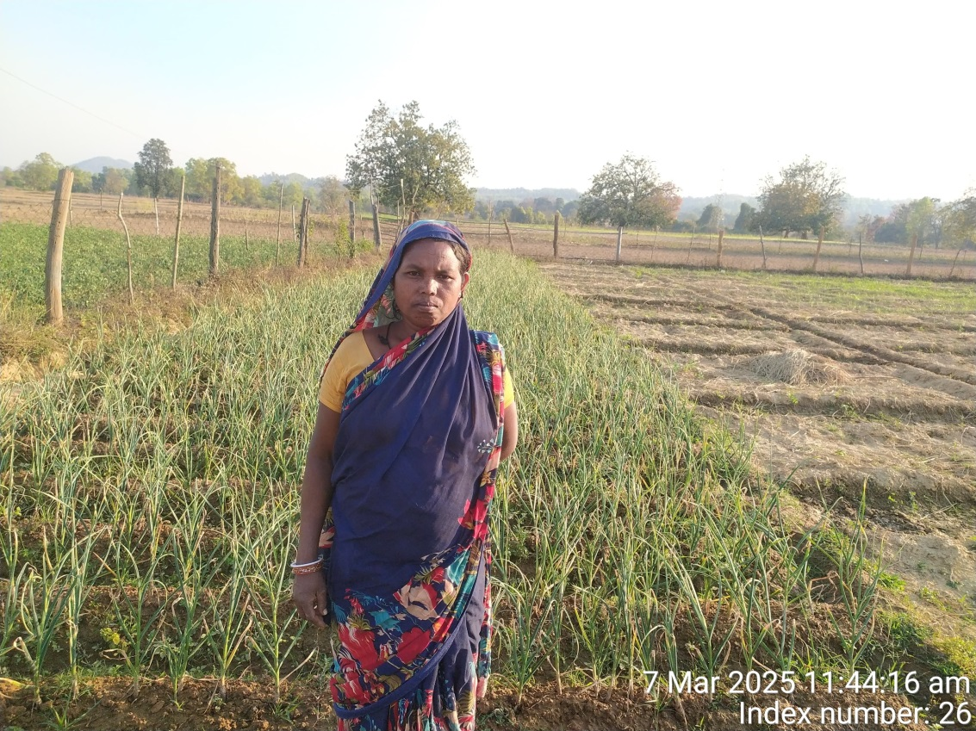

**Conclusion and Acknowledgment**

Sumitra Devi’s journey highlights the importance of resource utilization, financial planning, and proper guidance in overcoming poverty. Her success story serves as motivation for small-scale farmers facing similar challenges.

She expresses her gratitude to the **Catholic Charities** for their continuous support, training, and encouragement in helping her transform her livelihood. With the right support and determination, small farmers like Sumitra Devi can achieve financial independence and contribute to community development.

**Future Prospects**

To further enhance her productivity and income, Sumitra plans to:

* Expand her farming area to cultivate a greater variety of vegetables.
* Utilize improved irrigation techniques for better water management.
* Connect with local markets and bulk buyers for higher sales margins.
* Encourage and mentor other women in her community to take up farming.