**Vegetable Farming Became a Lifeline**

My name is Padmini Devi, and I am a resident of Beda Tulunda village, Bedakenduda Panchayat, Anandpur Block, West Singhbhum district. My husband, Samru Singh, and I have a family of six members. We were very poor and entirely dependent on paddy farming, which provided food but was insufficient to meet other household needs. Due to this, my husband and I also worked as laborers, earning only ₹80 per day—an amount too small to support our family.

**Turning Point**

In 2021, during a village farmers' club meeting, workers from Catholic Chatities were present. In that meeting, Richard Topno, a fieldworker from the organization, provided information about diversifying agriculture by incorporating vegetable farming and animal husbandry alongside paddy cultivation.

Inspired by this, I decided to start vegetable farming. However, due to a lack of capital, I could not start on a large scale. I used ₹800 from my labor earnings to purchase seeds. I bought one packet each of tomato and chili seeds, set up a nursery, and cultivated them on 10 decimals of land. The yield was excellent. I sold tomatoes at ₹30 per kg, earning ₹9,000, and chilies at ₹50 per kg, earning ₹3,500. After deducting my initial investment, I made a profit of ₹11,700.

**Expansion and Growth**

With this profit, I decided to expand my farming.

* **In 2022**, I cultivated tomatoes, chilies, and eggplants on 40 decimals of land with an investment of ₹4,000. This yielded an income of approximately ₹20,000.
* **In 2023**, I further expanded to 70 decimals, investing ₹12,000 in vegetable farming, which resulted in a total income of ₹76,000.
* **This year (2024)**, I plan to cultivate tomatoes, chilies, bitter gourd, eggplant, beans, watermelon, cauliflower, and bottle gourd.

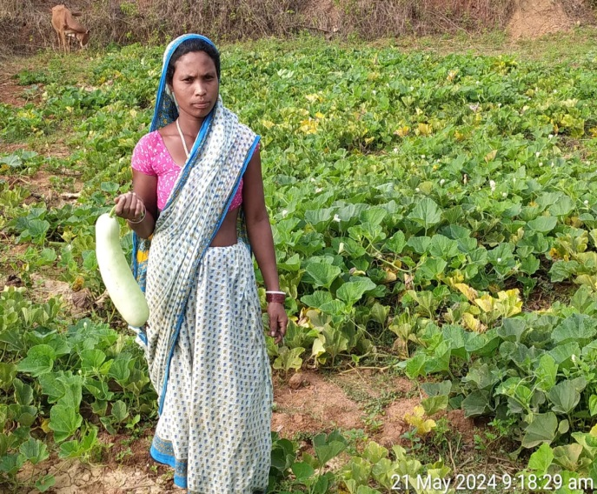

**Diversification into Animal Husbandry**

Alongside vegetable farming, I have also taken up animal husbandry. I currently own:

* 2 oxen
* 5 goats
* 15 chickens

Additionally, with support from the ATMA Department, I received an irrigation pump set worth ₹6,000, which has significantly helped in my farming activities.

**Impact and Transformation**

With the support of the organization and my hard work, my life has undergone significant positive changes:

* Improved farming methods and diversified crops
* Increased family income and food security
* Better diet and living conditions
* Growth in livestock resources
* A secure future for my children