**Rising Against the Odds: Raghunath Singh’s Journey to Success**

My name is Raghunath Singh, and I am a farmer from Beratulunda village, Bedakenduda Panchayat, Anandpur Block, West Singhbhum district. I belong to a family of six members, and due to financial hardships, I had to take on the responsibility of supporting my family at a young age, which resulted in me discontinuing my education. Despite working hard, I struggled to provide for my family as traditional paddy farming and daily wage labor were not enough to meet our needs.

**Challenges Faced**

For many years, my family survived on paddy cultivation, which only provided enough food for household consumption. There was no surplus yield to sell and generate income. To make ends meet, I worked as a daily wage laborer in the village, but even this additional work could not cover my family’s expenses. The cycle of poverty seemed unbreakable, and I had little hope of improving my situation.

**Turning Point**

In 2019, I met Jageshwar Singh, a field worker from Catholic Charities. He introduced me to the idea of diversifying my agricultural activities by incorporating vegetable farming along with paddy cultivation. He also encouraged me to attend an agricultural training program at the panchayat level. This training proved to be a turning point in my life.

During the training, I learned modern farming techniques, including vegetable cultivation, poultry farming, and goat rearing. Inspired by this knowledge, I decided to take a bold step towards changing my farming practices. I also joined the Jagriti Farmers' Club in my village, where I regularly attended meetings and interacted with other farmers who were adopting innovative methods.

**Initial Efforts and Failures**

My first experiment was planting 100 papaya plants, but due to a lack of water resources, the crop failed. This was a setback, but I did not let it discourage me. I realized that instead of giving up, I needed to find a more suitable crop that required less water and had higher profitability.

**Success with Vegetable Farming**

Determined to succeed, I started chili farming on 10 decimals of land. This time, the results were encouraging. With an investment of only ₹1,000, I managed to earn a profit of ₹10,000. Motivated by this success, I expanded my farming operations.

Using my earnings, I cultivated tomatoes on 40 decimals of land and chili on another 10 decimals. This time, my total investment was ₹3,500, and the returns were astonishing—I earned a profit of ₹42,000. With this income, I reinvested in my farm by purchasing fencing materials worth ₹16,000 and enclosed 1.5 acres of land to protect my crops.

**Diversification and Growth**

Encouraged by my growing success, I diversified my farming activities further. Alongside vegetable farming, I started poultry farming and goat rearing. Currently, I have 22 chickens and 12 goats, which provide an additional source of income for my family.

My progress didn’t stop there. Last year, I used my earnings from vegetable farming to purchase a motorcycle. This has made transportation much easier, allowing me to take my produce to markets more efficiently, further increasing my income.

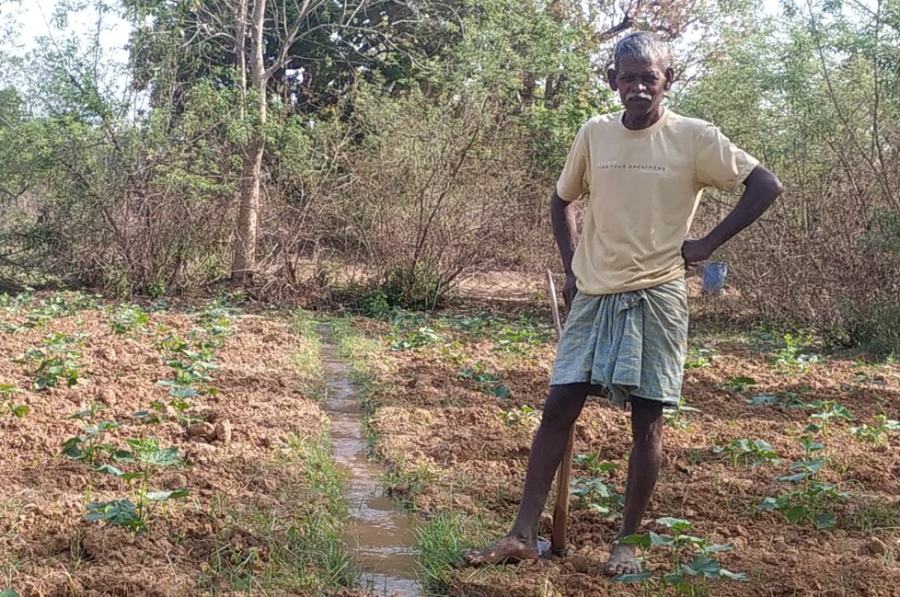

**Impact on My Family and Community**

The impact of these changes has been profound. My family’s financial situation has improved significantly, and we no longer struggle to meet our daily needs. I have gained the confidence to continue expanding my agricultural business, and I now serve as an inspiration to other farmers in my village. Many of them have approached me to learn about vegetable farming and poultry rearing, and I am happy to share my knowledge and experiences.

**Conclusion and Gratitude**

Looking back, I am proud of how far I have come. What once seemed like an endless cycle of poverty has transformed into a journey of growth and prosperity. I am deeply grateful to Catholic Charities and Samekit Jan Vikas Kendra for their guidance and support. Without their intervention, I might never have discovered these opportunities.

This journey has taught me that with the right knowledge, determination, and willingness to adapt, any challenge can be overcome. My goal now is to continue expanding my farming activities, provide a better future for my family, and help others in my community achieve similar success.