**From Hardship to Prosperity**

My name is Om Prakash Singh, and I am a resident of Dumirta village, Bedakenduda Panchayat, Anandpur block, in West Singhbhum district, Jharkhand. I come from a family of five members. Due to financial hardships, I had to bear the family’s burden at a young age, which forced me to discontinue my studies.

**Struggles and Challenges**

Earlier, I cultivated only paddy, which was just enough to meet my family's food needs, leaving no surplus for additional income. To support my family, I worked as a laborer in the village, but even then, our financial situation remained unstable. The lack of financial resources and opportunities made it extremely difficult for us to sustain ourselves. I often worried about the future and how I could improve our living conditions.

**A New Beginning**

In 2018, I met a staff member from *Catholic Charities* who advised me to diversify my farming by including vegetable cultivation along with paddy. He encouraged me to participate in a Panchayat-level agricultural training session. Through this training, I gained valuable knowledge about vegetable farming, poultry farming, and goat rearing. I learned about modern agricultural techniques, soil fertility management, water conservation, and organic farming. These insights gave me the confidence to try something new and take a step toward a better livelihood.

**Initial Struggles and First Success**

Motivated by this learning experience, I became a member of the *Jagriti Kisan Club* in my village and actively participated in its meetings. My first attempt was planting 100 papaya saplings, but due to water scarcity, the yield was unsuccessful. Despite this setback, I remained determined and decided to cultivate chili on 10 decimals of land. This time, the results were encouraging. My total investment in chili farming was Rs. 1,200, and I earned a profit of approximately Rs. 11,000. This small success gave me the motivation to expand my efforts further.

**Expansion and Growth**

With the profit earned from chili farming, I decided to take a bigger risk and expand my agricultural activities. I cultivated tomatoes on 40 decimals of land and chili on another 10 decimals. My total investment for this expansion was Rs. 2,600, and I made a remarkable profit of Rs. 34,000. Encouraged by this success, I reinvested my earnings to purchase a fencing net worth Rs. 15,000 and secured 1.5 acres of land, where I continued vegetable farming.

At the same time, I realized the importance of diversifying my sources of income. Along with vegetable farming, I ventured into poultry and goat farming. I started small, but over time, my livestock grew. At present, I own 18 chickens and 14 goats. These additional ventures not only provided me with extra income but also acted as a safety net in case of crop failure.

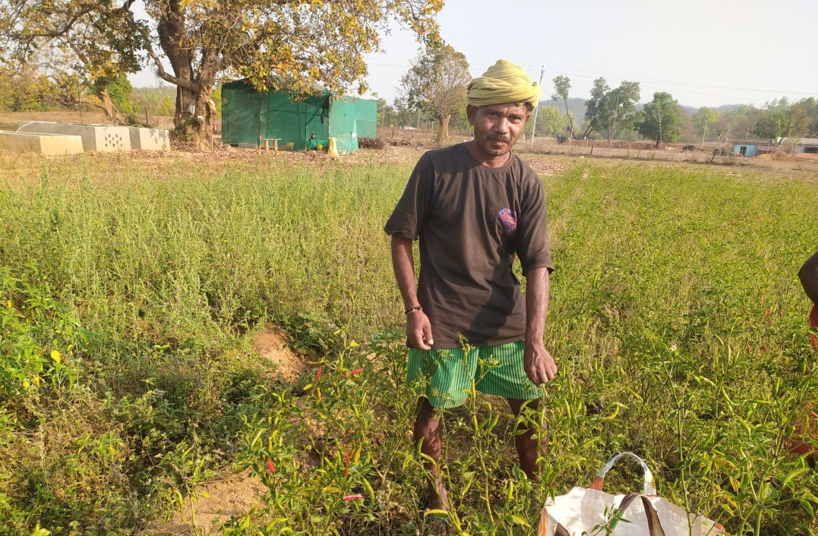

**Achievements and Present Situation**

As a result of my hard work and perseverance, I was able to purchase a motorbike last year, making it easier for me to transport my produce to the market. This has significantly reduced my dependence on middlemen and allowed me to sell directly to consumers at better prices. My farming business has become self-sustainable, and my family's economic condition has improved significantly.

Today, I am not only financially independent but also an inspiration to other farmers in my village. Many young farmers have approached me to learn about vegetable farming and animal husbandry. I am happy to share my knowledge and experiences with them, just as I was guided in the beginning.

**Gratitude and Future Goals**

I am deeply grateful to *Catholic Charities* and its dedicated staff for their guidance and support, which have played a crucial role in transforming my life. Their encouragement has not only helped me become a successful farmer but has also given my family financial stability and a brighter future.

In the future, I plan to further expand my farming activities by adopting more advanced agricultural techniques, increasing my livestock, and exploring organic farming on a larger scale. My dream is to see every farmer in my village financially secure and independent. With determination and the right guidance, I believe anything is possible.