**A New Path Through Hard Work**

My name is Jagnandan Singh, and my father’s name is Vishwanath Singh. I am a young farmer from Dumirta village in Anandpur block, West Singhbhum district, Jharkhand. Our family consists of five members, and our livelihood depends entirely on agriculture.

**Days of Struggle**

Our family’s financial condition was once very poor. We relied solely on paddy cultivation, which was not enough to meet our basic needs. Since our farming depended on rainfall, our crops often failed, leading to food shortages. The situation was so difficult that even getting enough food was a struggle. Due to a lack of money, my family and I had to work as laborers. Those were tough times for us.

**The Beginning of Change**

In 2022, a training program on agriculture and animal husbandry was organized at our village’s panchayat building. I participated in this training, where I learned about modern farming techniques and multi-crop farming for the first time. During the program, I met Richard Topno, a staff from Catholic Charities. After talking to him, I gained new enthusiasm and inspiration for farming. He encouraged me to take up vegetable farming and explained its benefits.

**A New Beginning in Farming**

I started my farming journey with 10 decimals of land, growing tomatoes, bitter gourd, and okra. Initially, I had only ₹1,150 as capital, which I invested in seeds, fertilizers, and other essentials. With hard work and proper care, my crops yielded good results, and when I sold my vegetables, I earned ₹8,500. This was my first success, which motivated me even more.

Gradually, I expanded my farming area and started producing vegetables on more land. Today, I cultivate vegetables on 30 decimals of land and earn a good income. With my hard work and the organization’s guidance, my life has transformed positively.

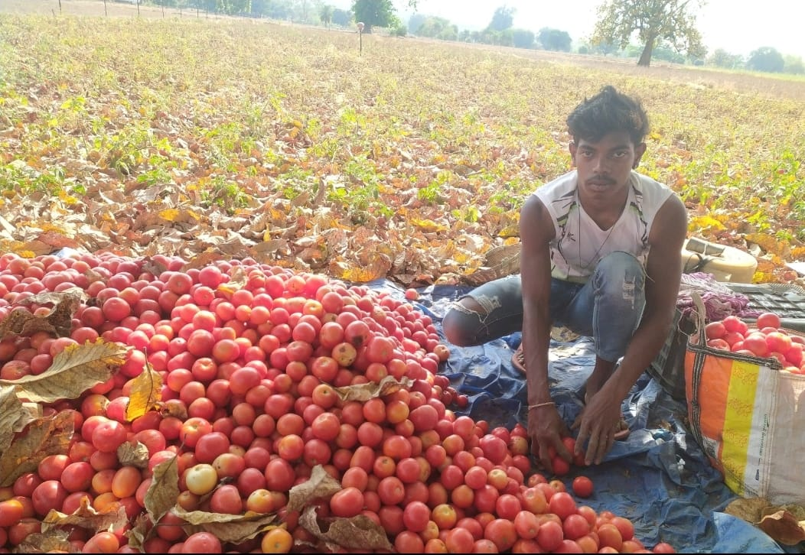

**Financial Improvement and Steps Towards Education**

The income from vegetable farming has improved my family’s financial situation. We no longer need to work as laborers, and our household runs smoothly. The most significant achievement is that I can now continue my studies. Currently, I am pursuing higher education at Manoharpur College. I feel happy that I can manage both my education and my family without depending on anyone.

**Gratitude towards the Organization**

Today, I am self-reliant and confident about my future. All of this has been possible because of the support of Catholic Charities, which provided me with guidance and a new direction. I sincerely thank the organization and its workers for showing the way to progress to farmers like me.

**A Message for Other Farmers**

My journey proves that life can change with the right knowledge, hard work, and confidence. I want to encourage other farmers not to rely only on traditional farming but to adopt modern techniques and new crops. If you move forward with determination, success will surely be yours.

*"There is no substitute for hard work; all that matters is making efforts in the right direction."*