**Seeds of Change: Lawmati Devi’s Path to Prosperity**

**Name:** Lawmati Devi  
**Village:** Buribil  
**Panchayat:** Berakenduda  
**Block:** Anandpur

**Phase of Struggle**

I am Lawmati Devi, and my family consists of four members. We have always practiced traditional paddy farming and did a little vegetable cultivation as well. However, due to old farming methods, crop yields were low, and our financial condition did not improve much. The primary goal of farming was only to grow food for our household, rather than making it a profitable business.

**Beginning of Change**

My life changed in 2005 when I got associated with Catholic Charities. By participating in various programs and activities organized by the organization, I learned about modern farming techniques. In 2018, I became a member of the *Uday Kisan Club*, where I got the opportunity to learn advanced agricultural techniques. The organization's staff, Rothin and Bhagat Sir, provided us with valuable knowledge about various scientific farming methods, completely transforming my perspective on agriculture.

**New Methods, New Learnings**

After joining the organization, I received training in various aspects, including:

* **Organic farming** – Using natural fertilizers and organic pesticides instead of chemical fertilizers.
* **Compost preparation** – Making organic fertilizers and pest repellents at home.
* **Line method farming** – Adopting scientific methods instead of traditional techniques to achieve higher yields.
* **Crop rotation** – Alternating crops instead of growing the same crop repeatedly to maintain soil fertility.
* **Season-based farming** – Selecting the right crops according to different seasons.

**Expansion in Farming and Increased Income**

Before 2018, I was farming on only **10-15 decimal** land. However, after receiving training, I expanded to **50 decimal** and gradually to **100 decimal**. My hard work paid off, and my income kept increasing every year.

| **Year** | **Farming Land (D)** | **Investment (₹)** | **Sales (₹)** | **Profit (₹)** |
| --- | --- | --- | --- | --- |
| 2019 | 60 D | 17,000 | 82,000 | 65,000 |
| 2020 | 60 D | 16,500 | 75,000 | 58,500 |
| 2021 | 60 D | 18,000 | 90,000 | 72,000 |
| 2022 | 70 D | 20,000 | 1,25,000 | 1,05,000 |
| 2023 | 100 D | 23,000 | 1,40,000 | 1,17,000 |
| 2024 | 90 D | 21,000 | 1,25,000 | 1,04,000 |

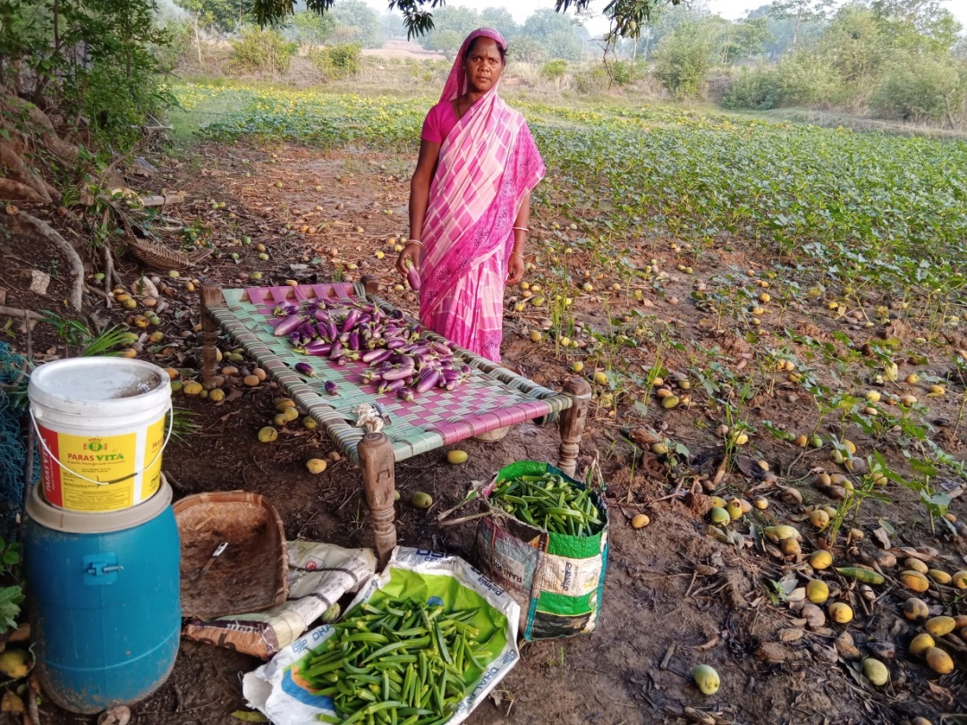

**Farming in All Three Seasons and Family’s Well-being**

Now, I cultivate crops in all three seasons—Kharif, Rabi, and Zaid—ensuring a steady income throughout the year. My financial situation has significantly improved compared to earlier. Today, I am able to send both of my sons to a private English-medium school, securing their future.

**Dream Home and Future Plans**

In 2023, I received my own **pakka house** under the **Pradhan Mantri Awas Yojana**, fulfilling my long-cherished dream. Now, I plan to:

* Build a **boundary wall** for better security for my family.
* Promote **integrated farming**, combining agriculture with animal husbandry and other sources of income.
* **Educate and inspire other farmers** to adopt modern farming techniques and improve their earnings.

**Gratitude to the Organization and Inspiration to Move Forward**

Whatever I have achieved today is largely due to Catholic Charities and *Uday Kisan Club*. The guidance of Rothin Sir and Bhagat Sir has changed my life.

I want to share a message with all farmers:  
**"If we work hard with the right techniques and proper guidance, farming can become a successful business."**