**The Inspiring Journey of Madga Singh**

**Introduction**

Madga Singh, a resident of Dumirita village, Anandpur block, West Singhbhum district, Jharkhand, once faced severe financial hardship. With a family of five, his livelihood depended entirely on agriculture, but the income was insufficient. Often, his family did not have enough rice to last the year, and meeting basic needs like education, healthcare, and daily expenses was a constant challenge. To support his family, Madga was forced to migrate for work, leaving his home and loved ones behind in search of a livelihood.

**The Turning Point**

In 2022, Madga Singh’s life took a turning point when he met Richard Topno, a field worker from Catholic Charities. Richard introduced him to the Chirag Farmers' Club, encouraging him to join meetings and learn new farming techniques. During one such session at the panchayat building, Rothin Sir from the organization provided detailed guidance on vegetable and paddy farming, explaining how farmers could earn better income through integrated farming methods.

**First Step Towards Success**

Inspired by this knowledge, Madga decided to give vegetable farming a serious try. He started by cultivating 10 decimals of land, planting tomatoes, chilies, and eggplants. His initial investment was ₹1,400, but when the crops were harvested, he earned a profit of ₹10,600. This first success gave him confidence, proving that farming could indeed be profitable.

**Expanding the Farm and Income Growth**

Encouraged by his success, Madga expanded his farming operations. Today, he cultivates 40-50 decimals of land, growing a variety of vegetables. His annual income has increased to ₹30,000-₹40,000, allowing him to provide a better life for his family.

Additionally, he has adopted modern techniques in paddy farming, ensuring that his family now has enough rice for the entire year, with surplus production for sale. This additional income has allowed him to send his children to a good school, afford better healthcare, and improve his family's standard of living.

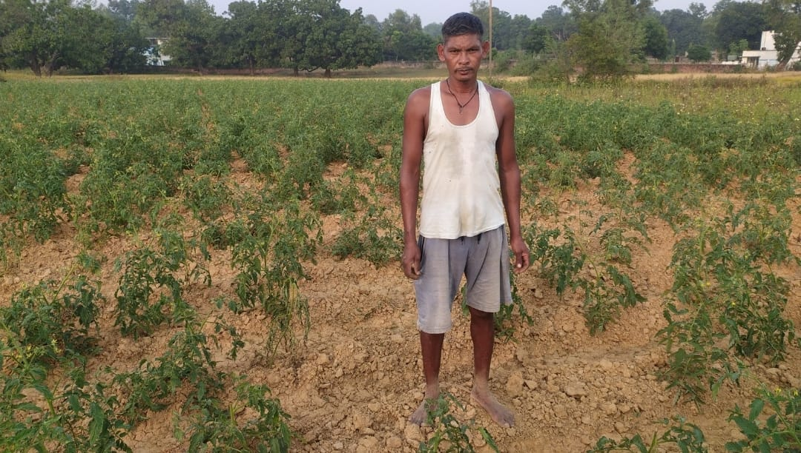

**A Vision for the Future**

Madga Singh’s journey from struggle to success has given him a new purpose. He dreams of helping other farmers in his village by sharing his knowledge and encouraging them to adopt vegetable farming and modern agricultural practices. His goal is to empower other farmers so that they too can achieve financial stability and self-reliance.