**Hard Work Changed My Fate**

I am Sunil Sardar, a resident of Tentla village in Potka block, East Singhbhum district, Jharkhand. My family of seven relied primarily on paddy farming, and for years, we only grew enough to sustain ourselves. While we occasionally cultivated vegetables, it was only for home consumption.

**A New Beginning**

Everything changed when I joined the **Farmers' Club**, a program run by **Catholic Charities** in our village. The training sessions I attended transformed my perspective on farming. I learned innovative techniques such as preparing organic fertilizers, natural pest repellents, and the use of **"Amrit Pani"** to enhance crop growth. These methods helped me understand how to improve productivity using sustainable practices.

Encouraged by **Mariam Didi**, a fieldworker from the organization, I decided to experiment with vegetable farming on **50 decimal** land. She also assisted me in purchasing seeds, boosting my confidence. I invested **₹1,500** in seeds and, for the first time, approached farming with dedication and strategy.

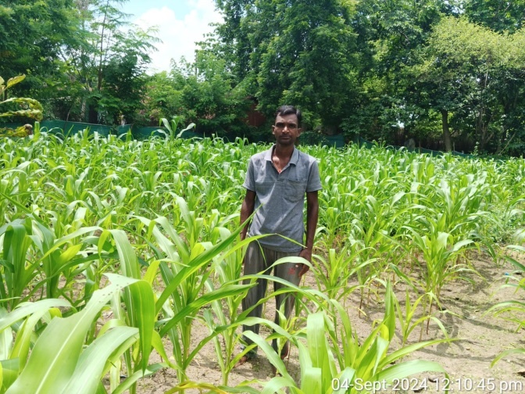

**The Turning Point**

With my newfound knowledge, I cultivated vegetables like **beans, okra, tomatoes, bitter gourd, sponge gourd, and chilies**. The results were remarkable—my earnings soared to **₹55,000** in a single season. The success motivated me to expand my efforts further.

Taking **Mariam Didi’s** advice, I reached out to the **BTM (Block Technology Manager) of the ATMA department**. With their support, I acquired a **drip irrigation system worth ₹70,000 for just ₹6,000**, ensuring efficient water management for my farm.

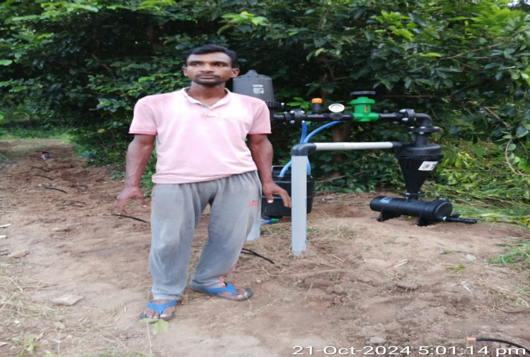

**A Brighter Future**

Today, I cultivate vegetables on nearly **one acre of land**. The financial stability from farming has transformed my family's life. My son is now enrolled in an **English-medium school**, and our household is no longer struggling to make ends meet.

I am deeply grateful to **Catholic Charities**, especially **Mariam Didi, Bhagat Ji, and Rothin Sir**, whose guidance and support helped me achieve this success. Their encouragement gave me a **new direction and purpose** in life.

**From a struggling farmer to a successful vegetable grower, my journey proves that with knowledge, perseverance, and the right support, hard work can indeed change one’s fate.**