**Towards Self-Reliance**

My name is Kishor Khakha. I am a young farmer from Burutulunda village, Bedakenduda Panchayat, Anandpur block, West Singhbhum district. There are five members in my family, and our livelihood primarily depends on agriculture. Earlier, we practiced paddy and vegetable farming on a very small scale, which was not enough to strengthen our financial condition. To earn a living, I had to migrate to other states in search of work. However, despite getting work, I could not save much, and I was unable to spend time with my family.

Initially, I cultivated only 5 decimals of land, which produced just enough food for our household. In 2021, a meeting of the Jharna kisan Club was held in our village, where Richard Topno, a field worker from the organization, was present. He invited me to attend the meeting. There, I learned many important aspects of farming, such as maintaining proper plant spacing and using organic fertilizers. Later, the organization provided me with agricultural training, which further improved my understanding of farming.

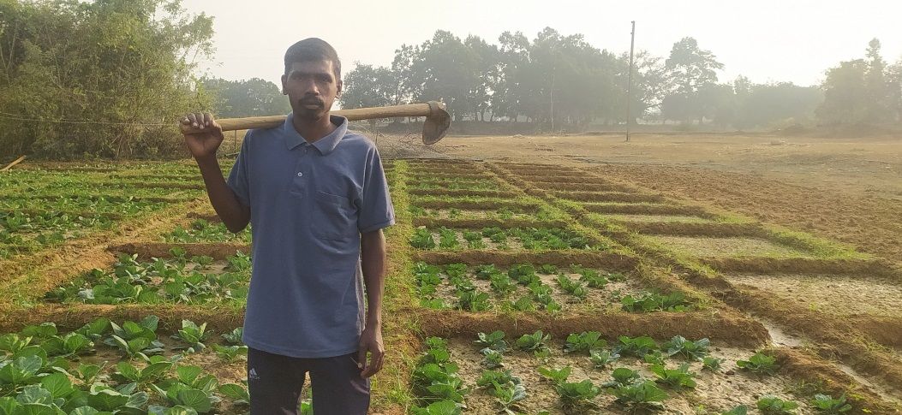

After this, I decided to expand my farming with the help of my father. I started tomato cultivation on 10 decimals of land, with a total investment of ₹1,100 (₹300 for seeds and ₹800 for labor). This farming yielded an income of ₹5,600.

In 2022, I expanded my cultivation to 20 decimals, growing tomatoes, chilies, and bitter gourd. The total cost was ₹1,400, and I earned ₹12,000.

In 2023, I further expanded my farming and invested ₹1,800 in crops, which generated a profit of ₹19,000.

In 2024, I invested ₹5,500 in farming, and this resulted in an income of ₹35,000.

Now, I have decided to focus primarily on vegetable farming. This year, I am planning to cultivate bitter gourd, okra, and bottle gourd, and I have already begun preparations.

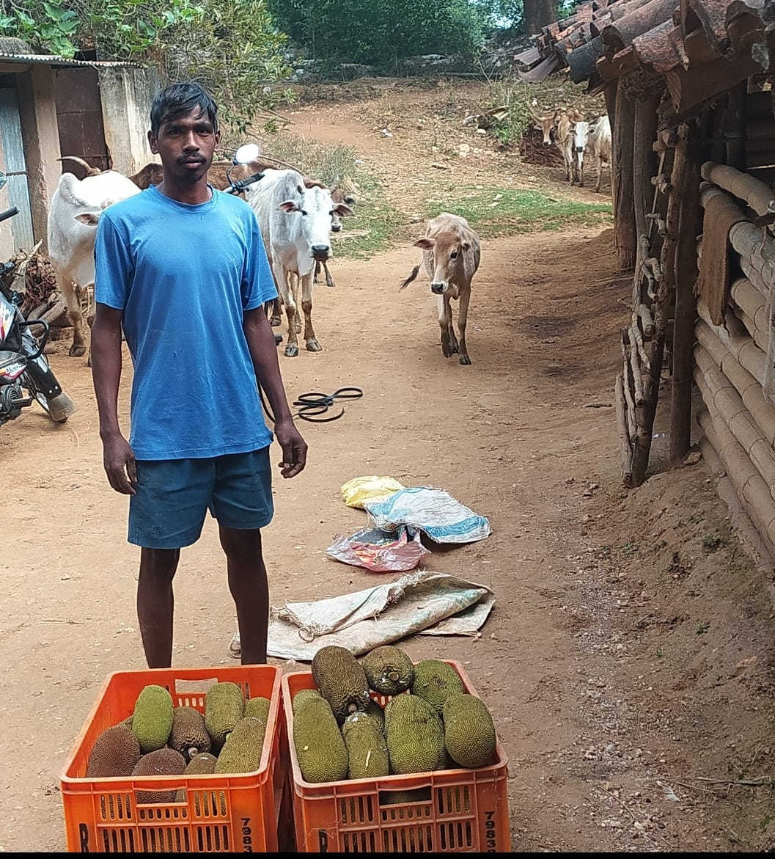

Vegetable farming has significantly improved my family's financial condition. We now have sufficient food, and I can save money as well. I have also stopped migrating for work and have dedicated myself fully to farming at home. Additionally, I have started animal husbandry, which has further increased my income.

I am deeply grateful to the Samekit Jan Vikas Kendra organization and its field workers, who have guided me on this new path and helped me advance in agriculture.