**Success Story**

**Vegetable farming became the basis of life**

My name is Mikhel Khakha, father – Pitrus Khakha, village – Burutulunda, Panchayat – Bera Kenduda, block – Anandpur, district – West Singhbhum, Jharkhand.

I am a farmer. There are a total of 7 members in my family. My family was very poor and depended only on paddy farming due to which we could not even meet the household expenses. I also work as a laborer to meet the household expenses and children's education. Due to poverty and hardship, I fell into bad company and started taking alcohol and smoke. In the year 2019, when I met Catholic Charities worker Jageshwar Singh and he told me to form a farmers club in the village. I also told this to other people of the village. Then we all together agreed to form a farmers club in the village. In 2020, we held a meeting and formed a farmers club which was named Jharna Kisan Club. Office bearers were selected in the club in which I was selected as the treasurer of the club. After the formation of the farmers club, club meetings started being held every month. In which I used to be present in every meeting. From time to time, training was given by the organization at Panchayat level in which I always participated. Training on vegetable farming was organized by the organization in Jamshedpur in which I participated, due to which I learned a lot about vegetable farming. Information received Earlier; I used to do vegetable farming on my 10 decimal land from which I got only enough vegetables to eat. After taking training, I increased the area of land for farming and started vegetable farming in 2 seasons. I bought a pump set machine. Bought and got the facility of irrigation from the drain water on the side of the field. After training, I did farming using the method which resulted in good yield and higher profits when sold in the market. With the remaining money, I did farming for the next time. Bought seeds. In this way, I expanded my farming land and started doing farming in larger quantities. Currently, I do only vegetable farming on 1 to 1.50 acres of land. My annual income from vegetable farming is 90 thousand to 1 lakh 20 thousand rupees. My daughter earlier studied in a government school, now I have enrolled her in St. Joseph's School, Charbandia. Presently she studies in 10th class.

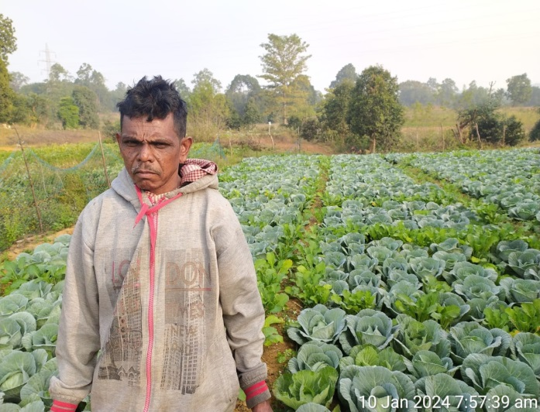 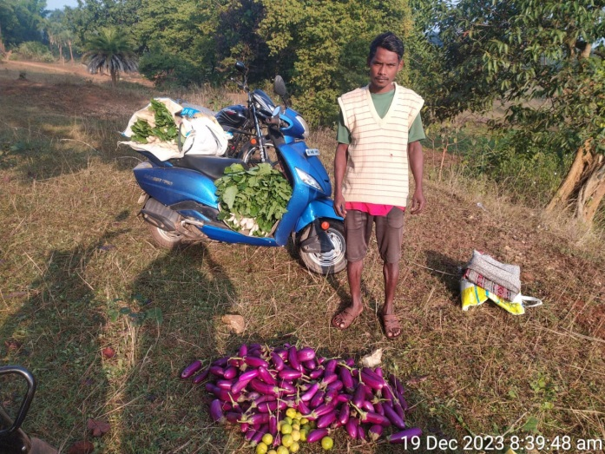

I have bought a scooty with the income from vegetable farming which makes it easier for me to sell vegetables in the market. I have completely given up alcohol addiction, due to which I am in the position I am today. In the future, I plan to buy a goods carriage auto. So that I don't have to depend on anyone to sell vegetables in the market.

I thank all the organization personnel for the change in my life and for giving me the right guidance.